

Smart Window Climate Control System with Automated Temperature Regulation

A Project Presented to

The Faculty of the College of Applied Studies

University of Bahrain

In Partial Fulfillment of the

Requirements for the Associate Diploma in

Network Administration

(If an image is appropriate, insert it in the space between the title and name)

**Name : MOOSA JAFFAR SALMAN ID No : 202006415**

30th May 2023

**Applied Network Design and Development (CEA291)**

**Mr. Mohamed Hassan Fardan**

# Acknowledgement

for enabling us to present this project in the best form that we wanted to be, we would like to thank our supervisor of this project, Mr. Mohamed Hassan Fardan for his valuable help and advice to come out with this project. We thank our faculty and doctors that provided us with all the knowledge. Most of all we are all thankful for our families for their endless love, assistance, support and encouragement. And for our friends for their understanding and support for us to complete this project.

# Abstract

In response to the escalating demand for energy-efficient solutions in home management, this project introduces a pioneering Smart Window Opener—a technology-driven alternative to traditional air conditioners. The innovation operates intelligently, gauging internal temperatures and autonomously deciding whether to open or close windows. Users have the flexibility to preset their desired temperatures, enabling personalized climate control.

The system integrates cutting-edge sensor technology, with internal and external temperature sensors serving as its sensory apparatus. The ESP32 microcontroller acts as the brains, processing real-time data to execute precise commands for window manipulation. An Electric Window Opener, strategically affixed to the window frame, serves as the responsive actuator.

The project's objective is to create an energy-efficient, user-friendly solution to regulate indoor temperatures, offering a viable substitute for conventional air conditioning systems. By seamlessly combining sensor data, microcontroller intelligence, and an electric actuator, this Smart Window Opener presents an innovative and environmentally conscious approach to indoor climate control.

This abstract encapsulates the essence of a project that not only addresses the growing need for energy efficiency but also aligns with the contemporary integration of technology into daily living.

# Table of Contents

Acknowledgement 2

Abstract 3

Table of Contents 4

Table of figures 6

1 Introduction 7

1.1 Project Background 7

1.2 Aims and Objectives: 8

2 Theoretical Background & Methodology 9

2.1 The issue with Air conditioning 9

2.2 Solutions to air conditioning electricity consumption 10

2.2.1 Higher AC Efficiency 10

2.2.2 Solar Power 10

2.2.3 Smart shaded windows 10

2.2.4 Using smart home automation systems 11

2.2.5 Opening and closing windows 11

2.3 Window climate control systems overview 13

2.3.1 Automatic Sliding Window openers 13

2.3.2 Automatic Top Hinge Window openers 13

2.3.3 Multi-purpose Automatic Window openers 14

2.4 Project Automatic control Principle 15

2.5 Project hardware components 16

2.5.1 Window Opening Device 16

2.5.2 Microcontroller (MCU) 16

2.5.3 Motor Driver 17

2.5.4 Temperature & Humidity Sensor 17

3 Project Implementation 18

3.1 Project Flowchart 18

3.2 Troubleshooting 19

3.2.1 overheats : 19

4 Software Explanation 19

4.1 ESP32 Programming 19

4.1.1 Connect to wifi: 19

4.1.2 Sinic and Application Setup: 20

4.1.3 Window mode 21

Interface Setup for application 23

4.2 Web interface 23

4.2.1 How the site was connected with the ESP32 device 23

4.2.2 How to control from web 23

5 Results and Analysis 23

5.1 Energy Consumption Reduction: 23

5.2 Temperature Regulation Efficiency: 24

5.3 User Satisfaction and Customization: 24

5.4 Alternative to Air Conditioners: 24

5.5 Conclusion: 24

6 Conclusions and Recommendations 24

6.1 Conclusions 24

6.2 Recommendations 25

6.2.1 Integration with Smart Home Ecosystems: 25

6.2.2 Enhanced Connectivity: 25

6.2.3 Energy Monitoring Features: 25

7 References 26

Appendix A: Proposal form 27

Appendix B: Prototype 28

Appendix C: Project Management Framework 28

# Table of figures

Figure 1 Annual energy consumption in Bahrain for a typical villa. 7

Figure 2 Residential energy consumption distribution in Saudi Arabia 10

Figure 3 Total monthly electricity consumption of KSA & average temperature throughout the year. 10

Figure 4 SEER rating and AC unit cost 11

Figure 5 Sliding door prototype for automatic sliding window. 14

Figure 6 Automatic Sliding door opener 14

Figure 7 Top Hinge window opener 14

Figure 9 Multi-Purpose Automatic window opener 15

Figure 8 Smart window opener 15

# Introduction

## Project Background

Heating and cooling (air conditioning) is one of the main contributors to electricity consumption accounting for 45% of the total energy use in the residential sector worldwide (Center For Sustainable Systems - University of Michigan, 2023). In Bahrain, the air conditioning account for at least 70% of the electricity used in a typical villa annually (Dubey & Krarti, 2017). Even in the winter, air conditioning consumption reduces only by half approximately in Saudi Arabia which is comparable to Bahrain (Schlanger, 2018). The statistics shows that there is a large issue when it comes to cooling and heating households and other residential buildings and that we need to find solutions to reduce the electricity consumption of air conditioning. This issue is already huge worldwide and more significant in the GCC countries where the air conditioning account for the majority of energy consumption. A smart device which can regulate the temperature by controlling the opening and closing of the existing windows in homes is a great idea to reduce energy consumption caused by air conditioning. An example for Bahrain would be in the winter where instead of turning the air conditioning on, a desired temperature can be set for the room and the device would ensure to maintain that temperature by opening and closing the window or controlling the opening angle of the window. Another case is for areas where the weather changes drastically between day and night where at night, the air conditioner is turned off (it can be a smart controlled AC or turned off manually) and the window climate device starts working to provide the adequate temperature.

Figure 1 Annual energy consumption in Bahrain for a typical villa.

## Aims and Objectives:

**The Aim of this project:** Design and develop a smart system capable of autonomously regulating indoor temperature for residential application.

**Objectives of the Project:**

* **Affordable system:** The cost of the smart system shall be within the reach for the masses and most people so it can justify its use and energy savings.
* **Remote Monitoring and Control:** Establish a Wi-Fi connection to enable remote monitoring of sensor readings and system status. Security measures shall be implemented to ensure a secure and encrypted communication channel between the system and the mobile app.
* **Ease of use:** The smart system shall be easy to use and implement and this means that an application and an interface shall be developed where the user connects and use the device wirelessly. It shall have the potential to be integrated into other home automation systems like Google Home.
* **User defined control:** The system shall allow the user to input the preferred indoor temperature in a user-friendly interface and specify other relevant parameters like a time range or scheduling. These input parameters will define how the system behaves based on the personal preferences and specific environmental conditions to control the opening of the window. The user shall be able to control the opening and closing of the window through the application too.
* **Integration of the temperature sensor in the device:** The temperature sensor for measuring indoor temperatures shall be integrated in the system.

# Theoretical Background & Methodology

## The issue with Air conditioning

As explained earlier in the project background, air conditioning accounts for the majority of electricity consumption in the residential sector. To put that in another perspective, the global greenhouse gas emissions mostly come from energy consumption (Alarenan, Gasim, Hunt, & Muhsen, 2019). This shows the importance of reducing the air conditioning energy consumption as it also reduces the greenhouse emissions which helps the environment and the sustainable development goals (13 - Climate Action).

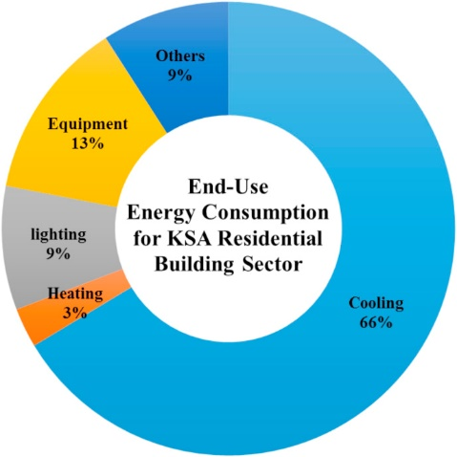Since Bahrain’s weather is comparable to Saudi Arabia’s weather, we can take some statistics from Saudi Arabia to analyze a concept. Saudi Arabia’s air conditioning accounts for approximately 66% of the total electricity usage (Krarti & Howarth, 2020). In addition, we can also see the graph below (Almushaikah & Almasri, 2020) which shows the total electricity consumption in each month in Saudi Arabia compared by the temperature graph and it is noticeable that the electricity consumed is reduced in the winter but not significantly. We can assume that we have approximately 4 months (30% of the year) where we can utilize the windows instead of air conditioners due to the good weather.

Figure 2 Residential energy consumption distribution in Saudi Arabia

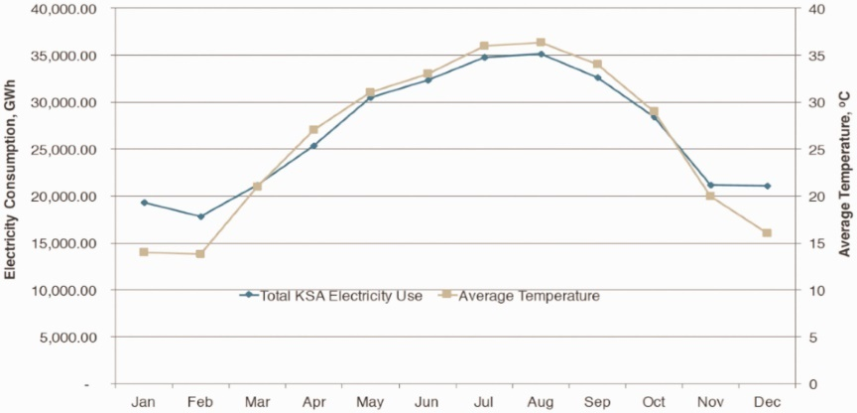

Figure 3 Total monthly electricity consumption of KSA & average temperature throughout the year.

## Solutions to air conditioning electricity consumption

To be able to find an applicable solution, first we must look into the available solutions for the issue and from there improve on existing solutions or apply new ideas to solve the problem. In this section, different solutions will be mentioned and compared to justify the most suitable.

### Higher AC Efficiency

One of the significant methods to reduce the electricity consumption for AC’s is by using a higher efficiency rating unit but that comes with a larger price tag as shown in the figures below. The reduction in energy savings can reach up to 65% with a 23 SEER rating compared by 38% with 13 SEER which is a 140% increase in the initial price which makes it very expensive for many consumers (Moor, 2023) which is not a relevant solution for this project.

Figure 4 SEER rating and AC unit cost

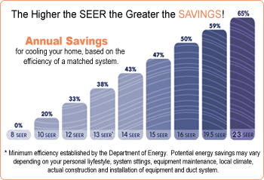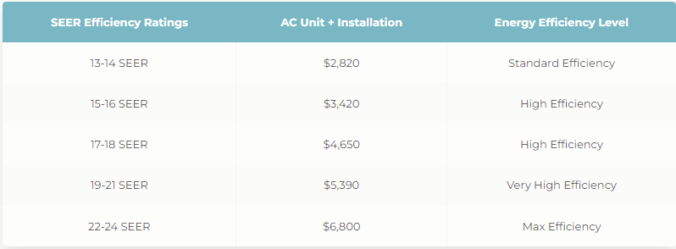

### Solar Power

Solar panels are great energy savers but the cost is also high as on average, it will cost approximately 7500 BHD for a house (Brill & Ogletree, 2023) and this makes it not viable for many households.

### Smart shaded windows

Smart shaded windows are estimated to save 25% of residential energy costs (McFadden, 2023) and they do not cost a lot compared by the previous solutions as the average unit cost is around 80 BHD and it is a viable option to be used in houses.

### Using smart home automation systems

This means using smart control devices like smart switches or controllers for Air conditioners for example to set schedules or automations which reduces the energy consumption. An example would be to use a sensor when the person leaves the room for a specific time, the air conditioner will shut down. This is a cheap and effective way of reducing the energy consumption but it will not be very useful when cooling or heating is needed as the unit will be needed to operate.

### Opening and closing windows

This is where this project idea is inspired from and opening the window in a good weather is very effective in reducing the energy consumption as the air conditioner will be turned off and no power will be needed. The main issue is that it is a manual operation mostly which for many people, it will be hard to implement. In addition, if the weather outside is too cold and the window is opened, the person will have to close it or close it partially constantly which is a difficult operation. Luckily, there are electric window opener solutions but the majority of them operate by remotes which also requires a constant attention from the person.

From the weather information for Bahrain and the GCC in general, we have about 4 months of the year that we can utilize without any air conditioning and only by controlling the window opening to maintain adequate room temperature which accounts for about 30% reduction in electricity costs annually for air conditioning. From December to March, the temperatures do not cross 24 degrees Celsius which is a comfortable maximum temperature. And if we go outside the GCC to Europe and other countries with colder climate, the effectiveness of this system becomes more prominent as there are lower temperatures throughout the year and such a system can be used in conjunction with inhouse heating or cooling systems depending on the weather of the place. The vision is to use it in a smart home environment as when the outdoor ambient temperature is adequate to cool the room, the smart window device is activated and the air conditioner is turned off automatically and when the outdoor ambient temperature is not able to provide the desired temperature, the air conditioner is turned on automatically which creates a flawless environment with minimal human interference.

This method of controlling indoor temperature shows to be effective as the reduction in energy savings shows with basic math and it also benefits the environment. Compared to the other solutions, it either costs a high amount or it is already an available solution in the market but this method of reducing the energy consumption by AC’s is an idea with a new implementation and will be considered as an improvement over the existing solutions in the market. So, in the next section, a comparison between different implementations of this idea will be conducted to determine how this device will be developed and built.

## Window climate control systems overview

### Automatic Sliding Window openers

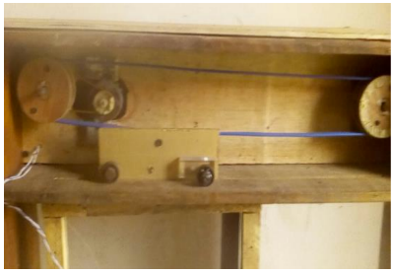A project for automatic sliding window in a research paper was developed which utilizes a microcontroller (Arduino UNO without wifi) to control the opening and closing of a sliding window (Owojori, Alade, & Olotuah, 2021) with an application but it does not integrate any smart features as there is no temperature sensor for example for the control but only controlled by the user. In addition, the idea for the opening of the window is through an ultrasonic sensor to detect and control the position.

Figure 5 Sliding door prototype for automatic sliding window.

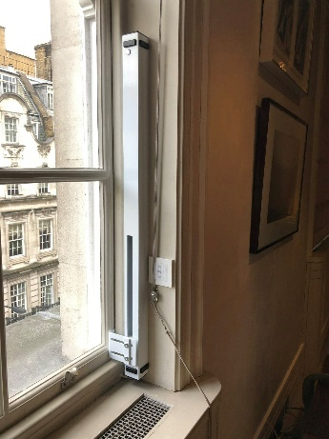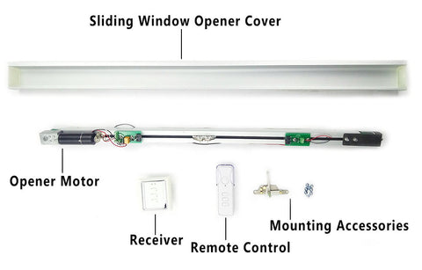

There are products available in the market which are specifically made for sliding doors and can be controlled by a remote control but does not include smart features with temperature sensors. In addition, this type of mechanism only works for sliding doors like the ones shown in the figures (Customizable Electric Sliding Window Opener, n.d.).

Figure 6 Automatic Sliding door opener

### Automatic Top Hinge Window openers

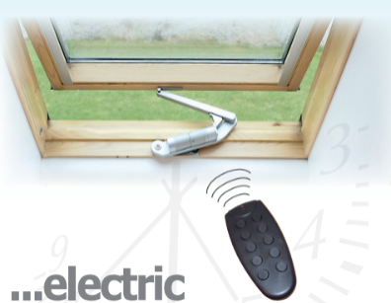This type of window openers is also similar to the sliding in the sense of a remote control and no smart features nor temperature sensor. In addition, this type has a limited opening angle and does not come in various sizes. Joris Roovers has created a similar system to be controlled with an Arduino Uno but it does not include any smart features (Roovers, 2020).

Figure 7 Top Hinge window opener

### Multi-purpose Automatic Window openers

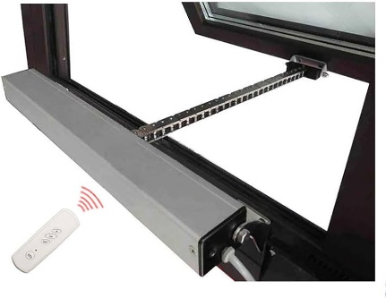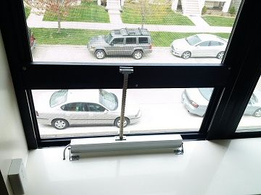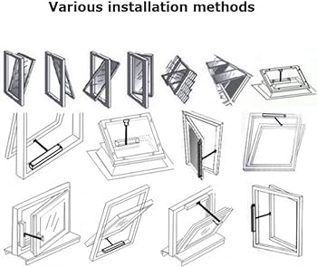

This type of window openers is the most versatile as it can be used for various types of windows and even sliding windows which is a great feature but most of them are controlled by a remote control. In addition, it comes in various chain sizes depending on the size of the window.

Figure 9 Multi-Purpose Automatic window opener

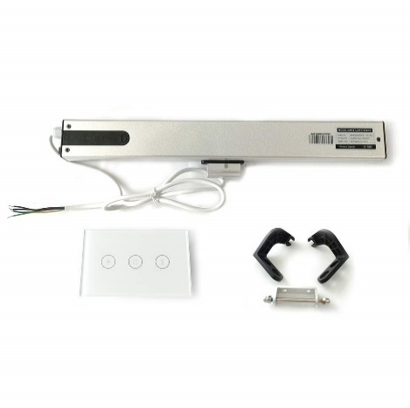Although this type of window openers can be found as smart, the features does not make the control easy. The smart openers of this type come with a smart switch which is the smart part that is connected to the Wi-Fi and all it does is to open the window fully, close it fully or stop the motor when desired manually. This does not allow for controlled partial opening of the window. In addition, there is no temperature sensor built in the device so it is hard to apply temperature based smart automations. This is the main reason for this project, is to allow for a flawless smart automation system from one device with a full control over the position and opening of the windows based on ambient indoor temperatures.

Figure 8 Smart window opener

After researching different types and solutions for controlling the indoor ambient temperature by a smart device, it has been found that the multi-purpose automatic window openers are the most suitable for this project and can be used and improved in a better smart system. The Idea is to take the electric window opener to integrate a Wi-Fi microcontroller, temperature sensor and other necessary parts to convert the device to a smart window opener as stated in the objectives.

## Project Automatic control Principle

The main principle is to provide the user with the ability to control the opening and closing of the window through an application using Wi-Fi.

Important aspects to be considered are:

* The user is able to control (open and close) the window through the application.
* The user is able to use a mode in the application for autonomous ambient indoor temperature control by inputting the desired indoor temperature where the device maintains the desired temperature autonomously by opening and closing the window.
* The autonomous control mode uses outdoor weather information data based on the location and decides weather the outdoor temperature is enough to cool the room to the desired temperature.
* In the case of internet shutdown, there is a web-based interface for the user which works on the local internet to still be able to operate the window opening and closing.
* The user can monitor the ambient indoor temperature and humidity.

## Project hardware components

### Window Opening Device

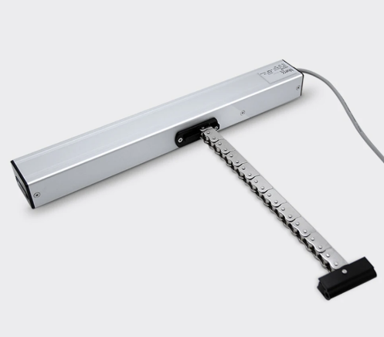The window opening device type has been selected and the product chosen uses 24V DC motor (Smart Electric Window Opener, n.d.). There are many variations of this device with different sizes and the chosen size is 200mm chain as it is small and enough for a prototype. We do not need to get a large unit since it will only be used for the demonstration of the project.

### Microcontroller (MCU)

A microcontroller is a compact integrated circuit (IC) that contains a processor core, memory, and programmable input/output peripherals. It is designed to execute specific tasks or control a specific set of functions within an embedded system. This is the core component which will transform the device into a smart device. The requirement is to attach the window opening device and the temperature sensors to the microcontroller to read the temperatures from the sensors and execute commands to the window opening device. In addition, the MCU shall have WI-FI for connectivity.

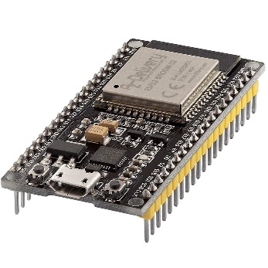There are many options in the market from Arduino company but its MCU’s are more expensive compared to ESP MCU’s. An ESP8266 would be sufficient for this project since it has more input/output pins than required but we already have an ESP32 MCU which has more features and just a little bit more expensive than ESP8266. So, ESP32 will be used for this project (ESP32 Development Board WiFi, n.d.).

### Motor Driver

To control the direction of the motor, there are two ways. The first is with using two relays to control the motor by switching contacts to reverse the polarity (Pieters, 2023). Another method is to use a motor driver board module which also allows for motor speed control in addition to the direction. It has been seen that the cost for the driver board module and the relays is basically the same in the market. So, a driver board module is preferred for the additional speed control feature which can be used to reduce the opening and closing speed to lower the noise from the motor.

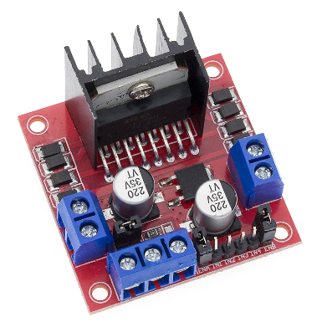 There are three famous modules used for motor control which are: DRV883 which can handle up to 10.8V and TB6612FNG which handles up to 15V but both cannot power the window opener. The third module is the L298N Dual H-Bridge Motor Driver which can handle up to 35V and 2A per channel. So, the Module L298N is chosen (L298N Driver Board Module, 2023).

### Temperature & Humidity Sensor

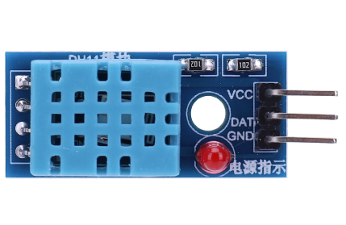As for the temperature sensor, the most used sensors are DHT11 and DHT22 (more accurate) in MCU projects and any of them can be chosen for this project (DHT11 Sensor, n.d.).

# Project Implementation

The main idea for this project development of a smart temperature regulation system with automated window control. The system architecture integrates outdoor and indoor temperature and humidity sensors, an ESP32 microcontroller, and a Electric Window Opener Communication protocols are defined to facilitate seamless interaction among these components.

## Project Flowchart

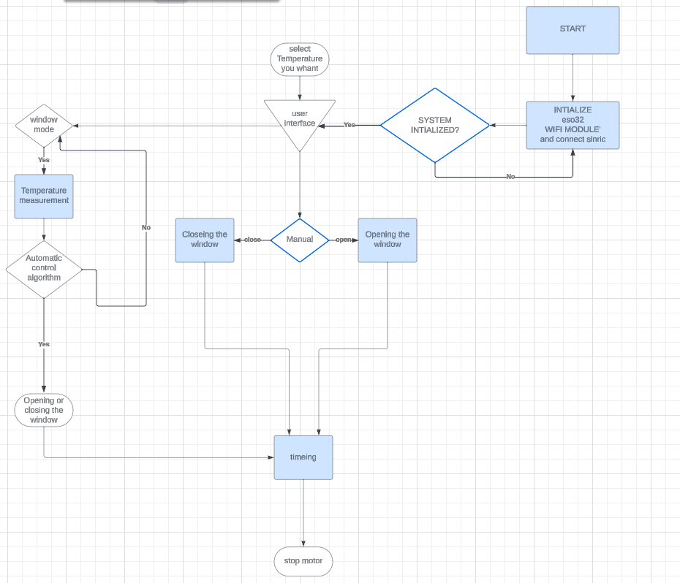

## Troubleshooting

### overheats :

The motor control unit overheats when the motor is running continuously without intermittent interruptions. When the motor runs continuously for a long time, it generates heat. If this heat is not effectively managed, it can lead to overheating problems in the motor control unit, which will lead to its breakdown or even complete shutdown.

# Software Explanation

## ESP32 Programming

### Connect to wifi:

This function sets up a WiFi connection by connecting to a specified network using the provided SSID and password. It waits for the connection to be established and then prints the local IP address.

### Sinic and Application Setup:

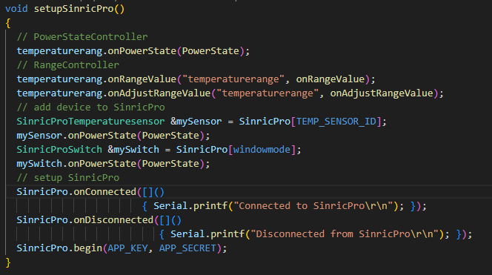

This function sets up the SinricPro library for controlling devices. It registers callbacks for power state changes and range value changes. It also sets up callbacks for when the device is connected or disconnected from SinricPro. Finally, it initializes SinricPro with the provided app key and secret.

#### Adjust temperature user select :

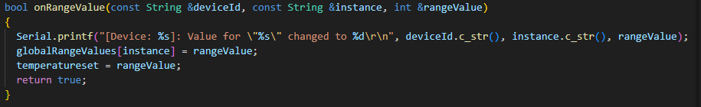

his function called onRangeValue that takes in three parameters: deviceId, instance, and rangeValue. It prints a message to the serial monitor, updates a global variable called globalRangeValues, sets a variable called temperatureset to the value of rangeValue, and finally returns true.

#### Power management

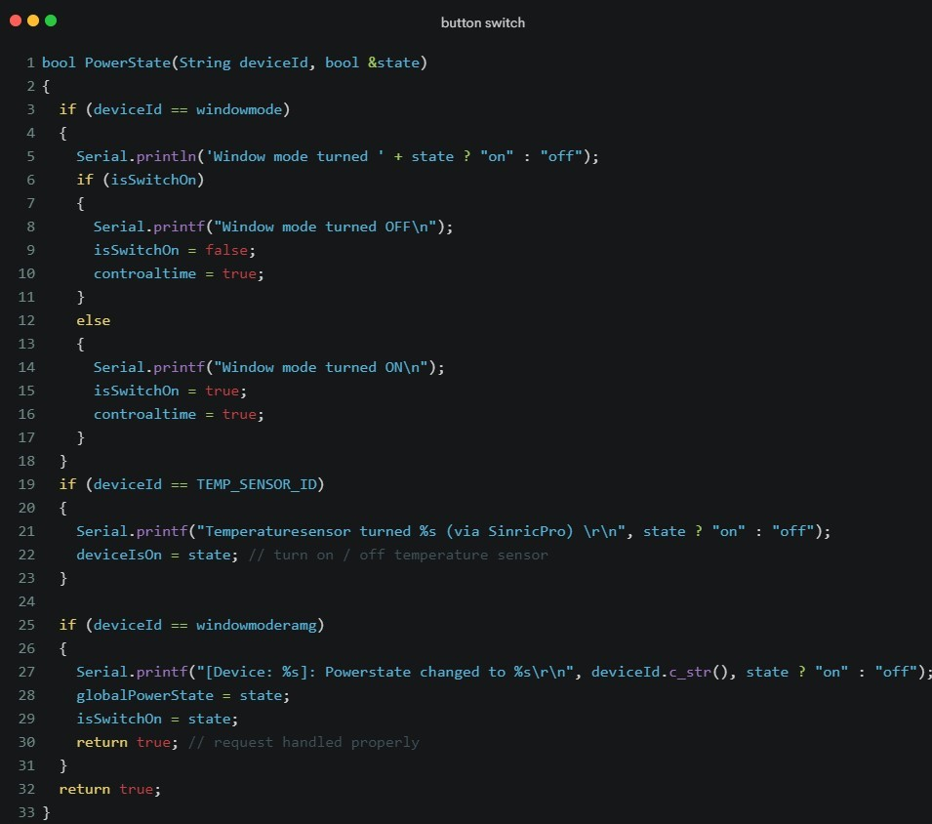

This function receives information from the Sonic Pro API

The name of the device and information about the on or off button there are several things we can wake up or turn on the temperature reader, Smart Window mode, manual window opener .

### 

To open window

### Window mode

window mode is a mode that controls the opening and closing of the window automatically without interference in an intelligent way that allows control over the room temperature and the external temperature range.

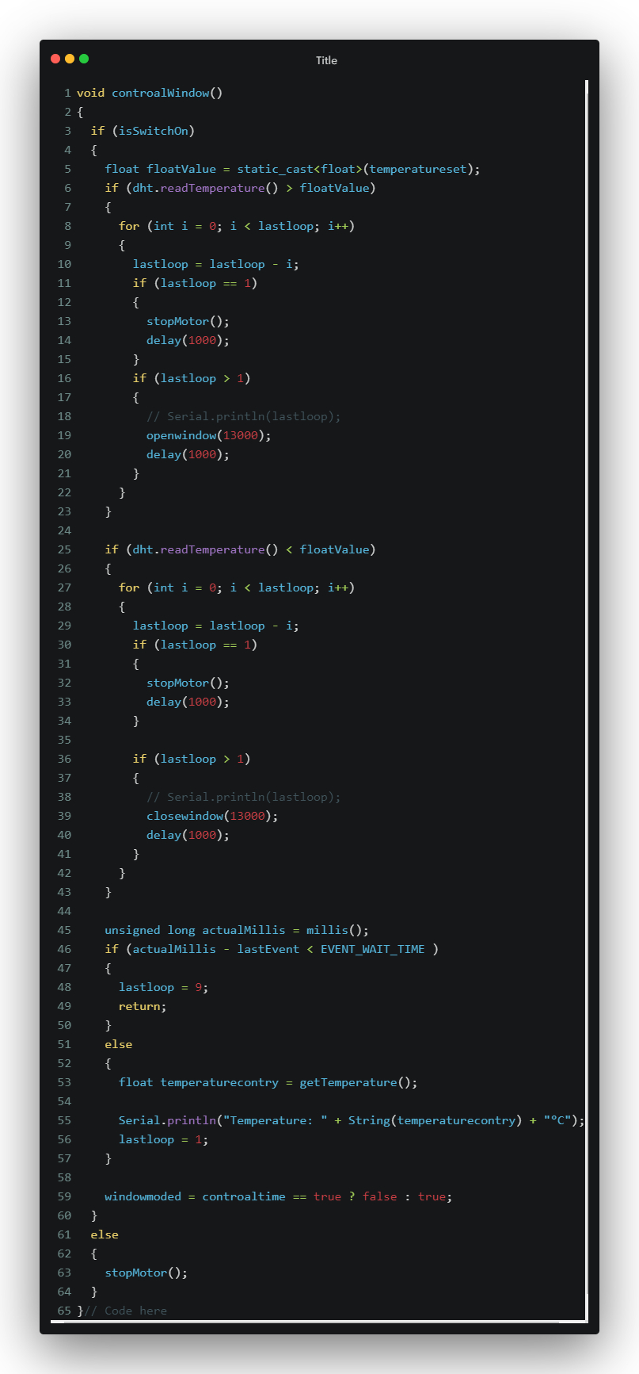

If the window mode is on and the current temperature is higher than the set temperature, the window is opened for a certain duration.

And If the current temperature is lower than the set temperature, the window is closed for a certain duration.

There is a wait period between events to prevent rapid switching.

## Interface Setup for application

## Web interface

The Website is built in JavaScript with the React library, which allows programmers to build websites

### How the site was connected with the ESP32 device

A request is sent from the built web application to esp32, which determines this request and what to do next

### How to control from web

The web application can be opened from any device, but provided that it is on the same network where the esp32 is connected

# Results and Analysis

## Energy Consumption Reduction:

The smart window opener project has demonstrated a notable reduction in electricity consumption compared to traditional air conditioners. By intelligently controlling windows based on internal temperature readings, unnecessary use of energy-intensive cooling systems is minimized.

## Temperature Regulation Efficiency:

The system's ability to read and analyze internal temperatures has proven to be effective in maintaining a comfortable indoor climate. Real-time data from temperature sensors enables precise control, ensuring that the desired temperature set by the user is achieved efficiently.

## User Satisfaction and Customization:

User feedback indicates a high level of satisfaction with the project's customization features. The option for users to set their preferred temperature allows for a personalized and comfortable environment, contributing to a positive user experience.

## Alternative to Air Conditioners:

The project has successfully positioned itself as a viable alternative to traditional air conditioners. Users appreciate the project's ability to provide climate control without the same level of electricity consumption, making it an attractive option for environmentally conscious consumers.

## Conclusion:

The results and analysis affirm the effectiveness of the smart window opener as an energy-efficient and user-friendly solution for temperature regulation. The positive outcomes in energy reduction, temperature control efficiency, user satisfaction, and environmental impact position the project as a successful and impactful innovation in home management.

# Conclusions and Recommendations

## Conclusions

The smart window opener project has proven to be a highly effective and energy-efficient solution, offering a compelling alternative to traditional air conditioners. By intelligently regulating windows based on internal temperature readings, the project provides a user-friendly and customizable approach to climate control. The significant reduction in electricity consumption positions it as a sustainable and cost-effective choice for users. As a conclusion, the project showcases great potential for widespread adoption and stands as a testament to the innovative strides in creating eco-friendly and smart home solutions.

## Recommendations

### Integration with Smart Home Ecosystems:

Explore opportunities to integrate the smart window opener with popular smart home platforms, enabling seamless interaction and compatibility with other smart devices for enhanced home automation.

### Enhanced Connectivity:

Consider expanding connectivity options to allow remote control and monitoring of the window opener through the internet. This can be achieved by integrating additional communication protocols or cloud-based services.

### Energy Monitoring Features:

Implement features that allow users to monitor the energy savings achieved by using the smart window opener. Providing insights into energy consumption patterns can reinforce the environmental and cost benefits of the solution.

# References

Alarenan, S., Gasim, A. A., Hunt, L. C., & Muhsen, A. R. (2019, July 30). Measuring underlying energy efficiency in the GCC countries using a newly constructed dataset. *Measuring underlying energy efficiency in the GCC countries using a newly constructed dataset*, pp. 31-44. doi:10.1007/s41825-019-00012-y

Almushaikah, A., & Almasri, R. (2020, December 17). Evaluating the potential energy savings of residential buildings and utilizing solar energy in the middle region of Saudi Arabia. *Sage Journals, 39*, 1-4. doi:10.1177/0144598720975144

*analog.com*. (n.d.). Retrieved from https://www.analog.com/media/en/technical-documentation/data-sheets/ds18b20.pdf

Azuela, H. (2020, January 5). *How to write report*. (HLA Publishing) Retrieved November 5, 2020, from www.hlapub.com

Azuela, L. S., & Azuela, L. (2020). *A Book of Life.* Manama: HLA Publishing.

Brill, R., & Ogletree, A. (2023, December 13). *How Much Do Solar Panels Cost In 2023?* Retrieved from Forbes: https://www.forbes.com/home-improvement/solar/cost-of-solar-panels/

Center For Sustainable Systems - University of Michigan. (2023, August). *Residential Buildings Factsheet*. Retrieved from University of Michigan: https://css.umich.edu/publications/factsheets/built-environment/residential-buildings-factsheet#:~:text=Wasteful%20energy%20uses%20include%20heating,oversetting%2C%20and%20standby%20power%20loss.&text=Heating%20and%20cooling%20account%20for,use%20in%20the

*Customizable Electric Sliding Window Opener*. (n.d.). Retrieved 12 22, 2023, from Amazon: https://www.amazon.com/Customizable-Electric-Sliding-Window-Opener/dp/B07SRXGKJ3

*DHT11 Sensor*. (n.d.). Retrieved 12 23, 2023, from AliExpress: https://www.aliexpress.com/item/1005006293880096.html?spm=a2g0o.productlist.main.1.558c4d12yIWO5U&algo_pvid=6e5c51b2-ad90-41e6-9c30-ce74b98113cb&algo_exp_id=6e5c51b2-ad90-41e6-9c30-ce74b98113cb-0&pdp_npi=4%40dis%21BHD%210.667%210.27%21%21%211.77%21%21%402

DHT11. (n.d.). *shop.evilmadscientist.com*. Retrieved from https://shop.evilmadscientist.com/productsmenu/716#:~:text=Good%20for%200%2D50%20%C2%B0,4%20pins%20with%200.1%22%20spacing

Dubey, K., & Krarti, M. (2017). *An Evaluation of High Energy Performance Residential Buildings in Bahrain.* Riyadh: King Abdullah Petroleum Studies and Research Center.

ESP32. (n.d.). Retrieved from https://randomnerdtutorials.com/getting-started-with-esp32/

*ESP32 Development Board WiFi*. (n.d.). Retrieved 12 23, 2023, from AliExpress: https://www.aliexpress.com/item/1005005704190069.html?spm=a2g0o.productlist.main.1.78ee7404tJxrPR&algo_pvid=27436ecd-6bb0-41da-a6c4-c59392e109e8&algo_exp_id=27436ecd-6bb0-41da-a6c4-c59392e109e8-0&pdp_npi=4%40dis%21BHD%211.952%210.18%21%21%2136.83%21%21%40

Krarti, M., & Howarth, N. (2020, April 27). Transitioning to high efficiency air conditioning in Saudi Arabia: A benefit cost analysis for residential buildings. *Journal of Building Engineering*, 1-12. doi:10.1016/j.jobe.2020.101457

*L298N Driver Board Module*. (2023, 12 23). Retrieved from Aliexpress: https://www.aliexpress.com/item/1005005973950288.html?spm=a2g0o.productlist.main.3.7f069fc5CZkRpE&algo_pvid=7cdc690f-2a3d-4c3a-a79e-2db729c67416&algo_exp_id=7cdc690f-2a3d-4c3a-a79e-2db729c67416-1&pdp_npi=4%40dis%21BHD%212.567%210.18%21%21%2148.44%21%21%40

McFadden, C. (2023, May 19). *Study finds that automated window shades can save 25% of energy costs*. Retrieved from Interesting Engineering: https://interestingengineering.com/innovation/study-finds-that-automated-window-shades-can-save-25-of-energy-costs

Moor, T. (2023, October 4). *What is a SEER rating?* Retrieved from HVAC.com: https://www.hvac.com/expert-advice/what-is-seer-rating/

Owojori, A., Alade, H., & Olotuah, A. (2021). Analysis of an Automatic Sliding Window. *JEEECCS, 7*(26), 9-16.

Pieters, A. (2023, 12 23). *ESP32 – Motor controller*. Retrieved from Studio Pieters: https://www.studiopieters.nl/motor/

Roovers, J. (2020). *Window Opener Project*. Retrieved from Joris Roovers: https://jorisroovers.com/posts/window-opener/

Schlanger, Z. (2018). *70% of Saudi Arabia’s electricity is used for air conditioning*. Retrieved from QUARTZ: https://qz.com/1284239/70-of-saudi-arabias-electricity-is-used-for-air-conditioning

*Smart Electric Window Opener*. (n.d.). Retrieved 12 23, 2023, from AliExpress: https://www.aliexpress.com/item/1005005796577034.html?spm=a2g0o.order_list.order_list_main.41.15741802t2NtN0

# Appendix A: Proposal form

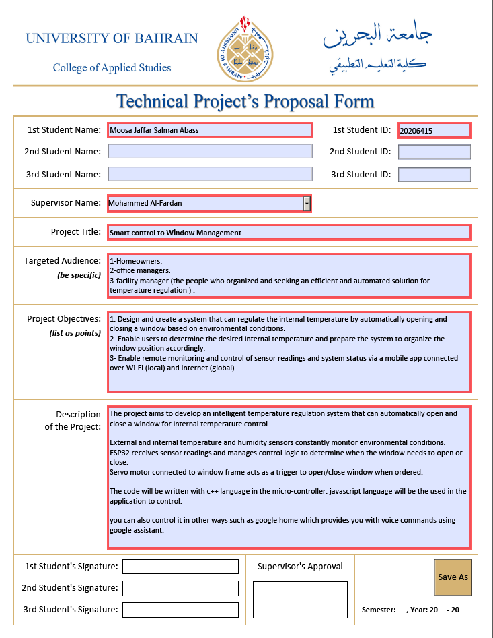

# Appendix B: Prototype

# Appendix C: Project Management Framework

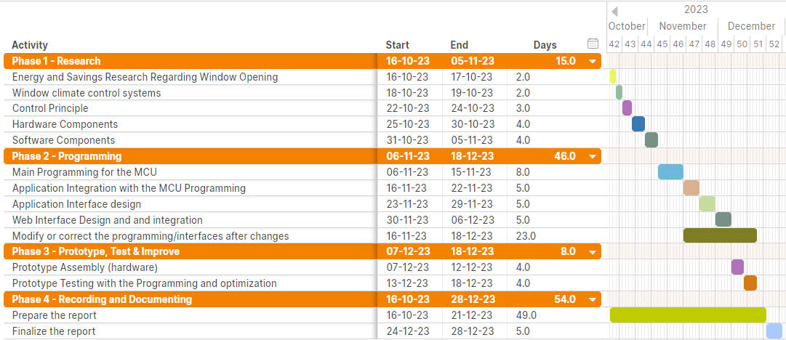Project Gantt Chart: used as the plan to follow the milestones and deadlines which is a management tool for the project.